**Lab1**

**Problem 2.1**

1. We have a non-zero element in rref and this indicates there is no solution for Ax=b.

MATLAB’s approximation (A\b) yields the following solution.

**Problem 3.1**

1. R4 is missing in the question diagram. Included it and solved.

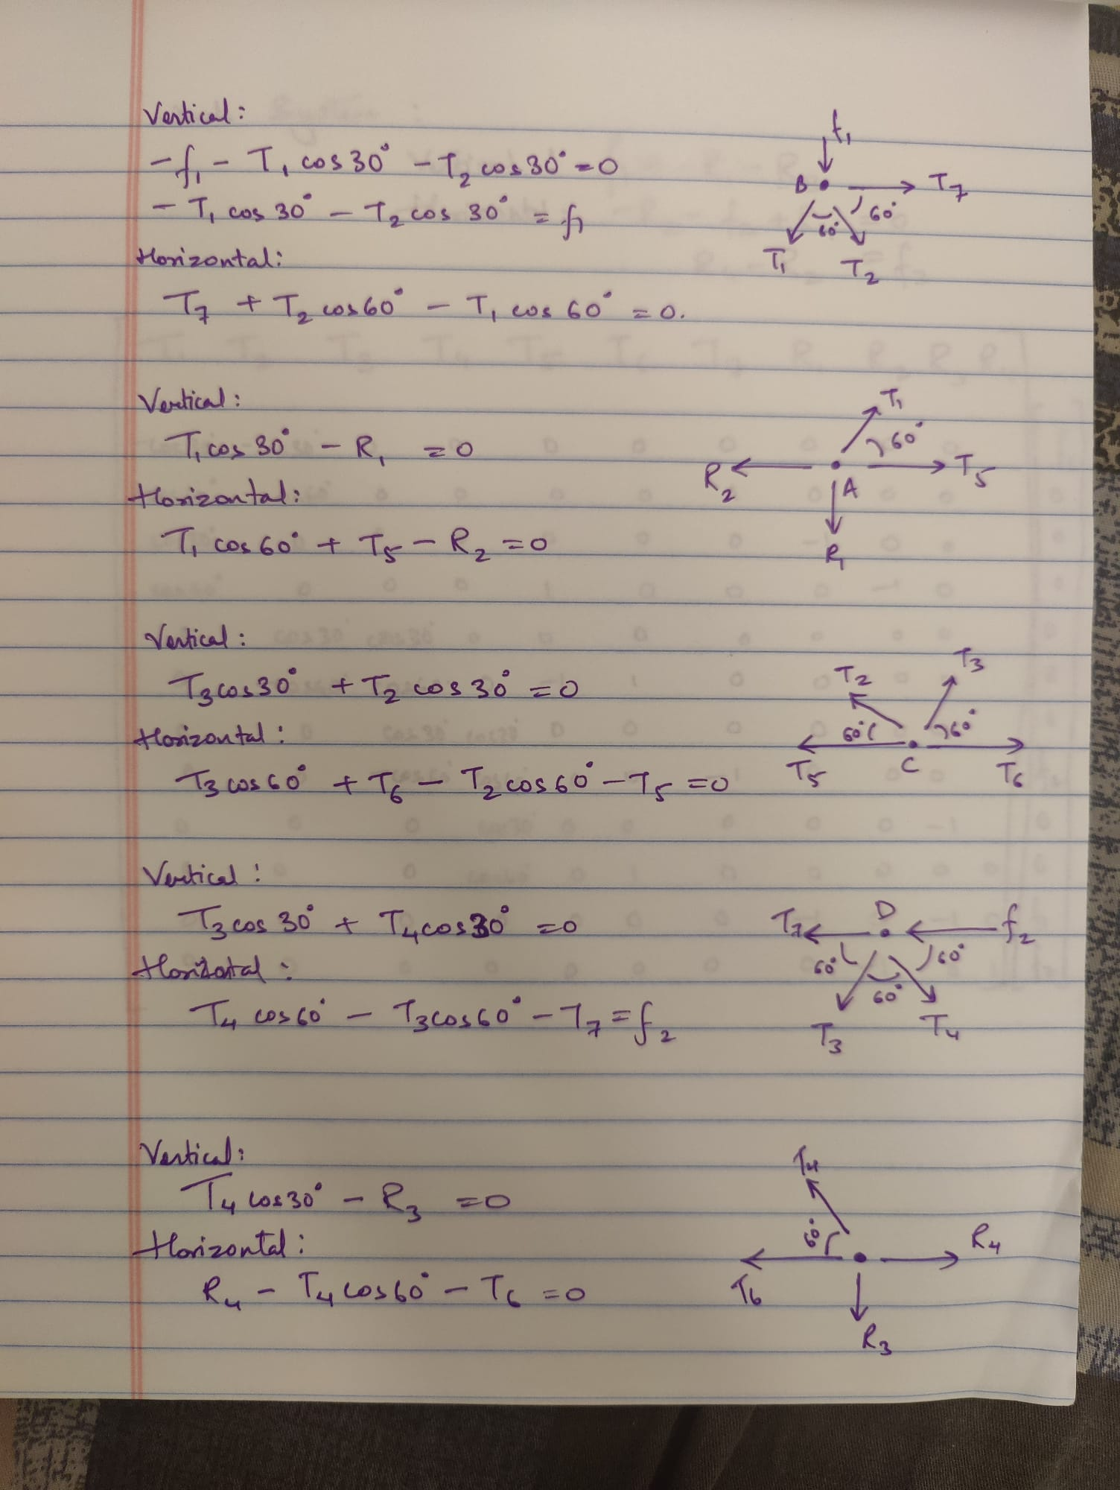

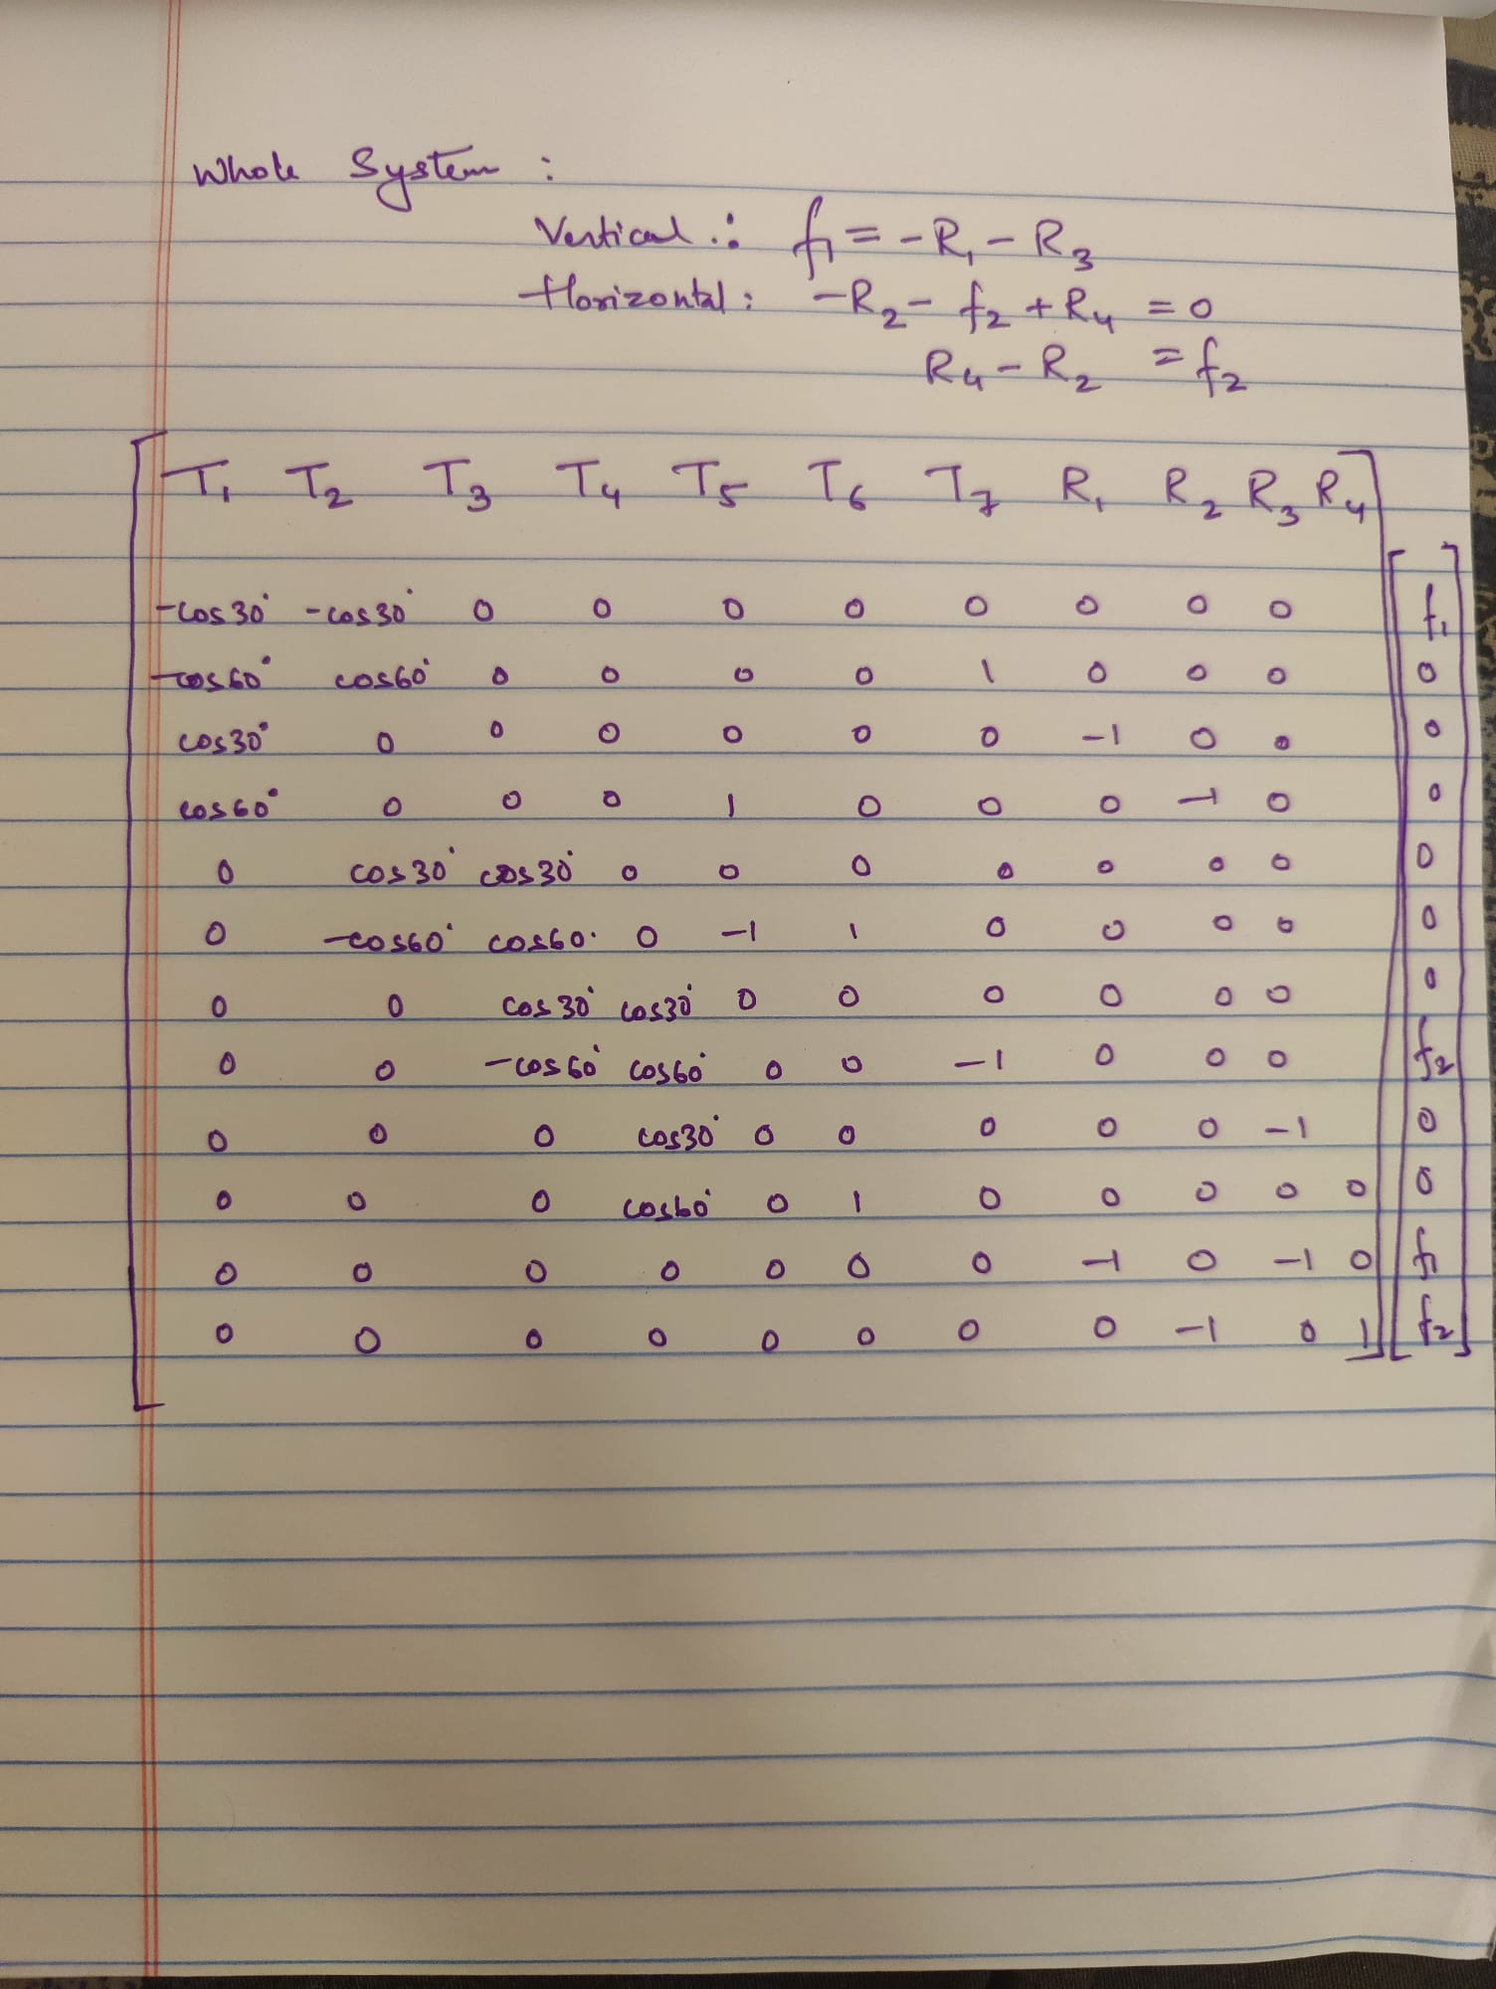

$\left(\begin{aligned}T1 \\ T2 \\ T3 \\ T4 \\ T5 \\ T6 \\ T7 \\ R1 \\ R2 \\ R3 \\ R4\end{aligned}\right)$ = $\left(\begin{aligned} -430.9401 \\ 315.4701 \\ -315.4701 \\ 315.4701 \\ -473.2051 \\ -157.7350 \\ -684.5299 \\ -373.2051 \\ -688.6751 \\ 273.2051 \\ 311.3249\end{aligned}\right)$

2.

$\left(\begin{aligned}T1 \\ T2 \\ T3 \\ T4 \\ T5 \\ T6 \\ T7 \\ R1 \\ R2 \\ R3 \\ R4\end{aligned}\right)$ = $\left(\begin{aligned} (2*3^(1/2)*f1)/(3*(3^(1/2) – 2)) \\ –(2*(3*f1 – 3^(1/2)*f1))/(3*(3^(1/2) – 2)) \\ – 2*f1 – (2*3^(1/2)*f1)/3 \\ (2*3^(1/2)*(f1 – 3^(1/2)*f1))/(3*(3^(1/2) – 2)) \\ -(3^(1/2)*(f1 – 3^(1/2)*f1))/(3^(1/2) – 2) \\ -(3^(1/2)*(f1 – 3^(1/2)*f1))/(3*(3^(1/2) – 2)) \\ -(6*f1 – 6*f2 – 2*3^(1/2)*f1 + 3*3^(1/2)*f2)/(3*(3^(1/2) – 2)) \\ f1/(3^(1/2) – 2) \\ (9*f1 – 2*3^(1/2)*f1)/(3*(3^(1/2) – 2)) \\ -(3^(1/2)*(3*f1 – 3^(1/2)*f1))/(3*(3^(1/2) – 2)) \\ (9*f1 – 6*f2 – 2*3^(1/2)*f1 + 3*3^(1/2)*f2)/(3*(3^(1/2) – 2))\end{aligned}\right)$

It is clearly visible that T3 and f2 are independent, therefore, change in f2 doesn’t change T3.

3.

If T3 = 1000 then,

$$- 2*f1 -\frac{2*3^{\frac{1}{2}}*f1}{3}=1000$$

* f1 ≈ -316.9873

for any value of f2.

**1b**

